The data unit is a Raspberry Pi 3 model B unit, with a connected communication board (Lan, USB A) and a display (size XX x XX); its dimension is XX x XX x XX mm.
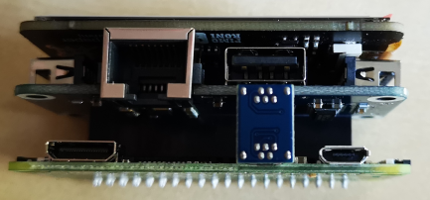
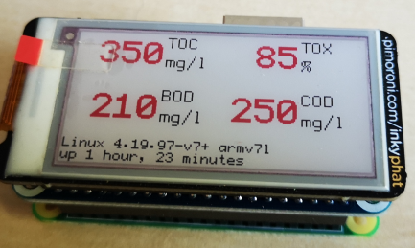
(Bild später ggf ersetzen)
The power supply can be performed with a common charging cable, for example of a cell phone. The connection cables to the data sources are common cable connections.
- JUMO AQUIS touch S: Lan. The MODBUS signal of the connected electrodes (pH, conductivity, temperature, and Oxidation Reduction Potential) is read and evaluated.
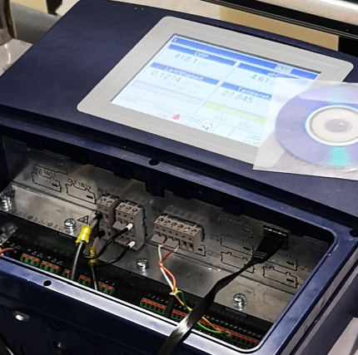
The transmission settings are 19200 baud, xxxxxx. The data from the JUMO box are send after receiving the command XXX
- LAR ToxAlarm: USB-RS232 converter, crossed RS232 port.
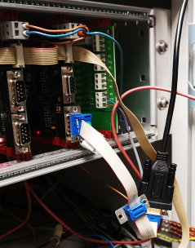
The transmission settings are 9600 baud, xxxxx. The data from the ToxAlarm analyser are send after receiving the command “S”.
- Analog signal input: have to be defined
The data are stored on a common data disk: ScanDisk micro with 16 GB.
This data collection unit stores all data in a uniform format at a configurable frequency. The data can be viewed:
- on the attached display,
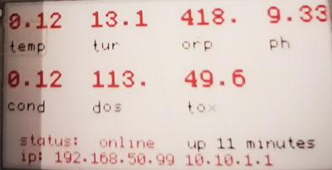
- on any Wlan comparing device, like computer or smartphone, using the messenger program “Telegram”, with using command /status
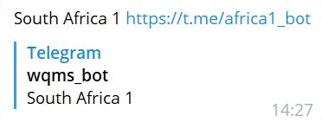
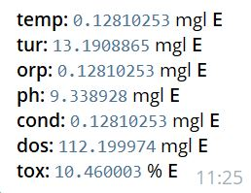
  - the actual value as table
  - (see picture XX): direct, with parameter name and unitthe actual or all data of a day or all data: in csv format. Command is /csv
(wenn du gerade einen file hast, bitte einfügen)
These files can be imported also in any table program using Unicode 8 as character set and comma as separator.
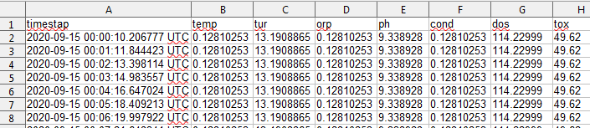
- on any Wlan comparing device, like computer or smartphone, using the data visualization and management program “ThingSpeak for Internet of Things”
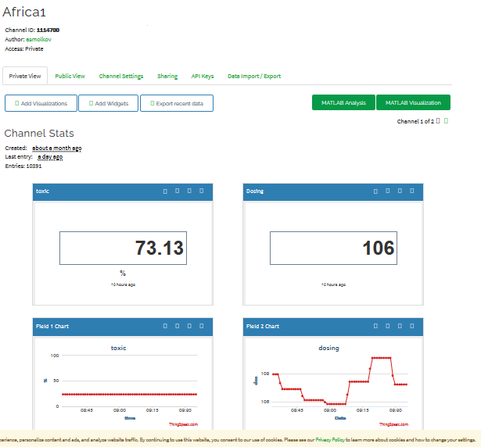
With the messenger program Telegram it is possible (beside viewing the data, see above), also to configure the different needed parameters in this data collection unit to keep it flexible. With the command /help the following command are possible:
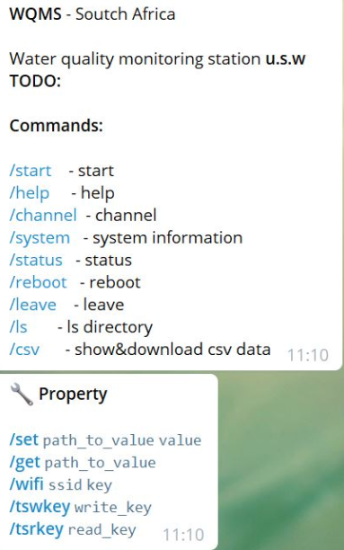
command for changing units of the chemical parameters:
welche Sachen sollte man noch weiter erklären? zB. Das Format der Befehle, ….. bitte schreibe ein paar Beispiele unten. Auch, wann dieser Befehl von wem gemacht werden sollte, z.B. Service

/start -start
- start the data input of device as defined in program properties
/help -help
- list the possible commands and properties
/channel -channel
- number of the chemical parameter viewed as defined in program properties
/system -system information
- shows the device properties as defined in program properties, including possible commands
/status -status
show the actual values of chemical parameter as defined in program properties, including of online status of the device
/reboot -reboot
- reboot the device. Necessary after changing the program properties
/leave -leave
- exit the device out of Telegram view
/ls -list directory
- was genau wird hier gelistet?
/csv -show&download csv data
- show a list of files names of measured data: for example, home/pi/.wpms/channels/20200909
/set -path_to_value value
- change settings of the configuration table of the chemical parameters, like units
ich habe es doch nicht hinbekommen, die Einheiten müssen sein:
temp: °C
orp: mV
pH: -
/get -path_to_value
- ???????
/wifi -ssid key
- ???????
/tswkey -write_key
- ???????
/tsrkey -read_key
- ???????

